A FIELD PROJECT REPORT ON

**GYM MANAGEMANT SYSTEM**

**Submitted**

*In partial fulfillment of the requirements for the award of the degree*

**BACHELOR OF TECHNOLOGY**

In

**COMPUTER SCIENCE AND ENGINEERING**

Submitted by

**Ayush kumar verma (231FA04F86)**

**T.sravya (231FA04378)**

**K.prem kumar (231FA04383)**  
**P.chandana priya (231FA04295)**

Under the Guidance of

**V.Nandini**

**Assistant Professor, CSE**



**DEPARTMENT OF COMPUTER SCIENCE & ENGINEERING**

**SCHOOL OF COMPUTER AND INFORMATICS**

**VIGNAN'S FOUNDATION FOR SCIENCE, TECHNOLOGY & RESEARCH (Deemed to be University)**

**Vadlamudi, Guntur -522213, INDIA.**

**April, 2025**



**CERTIFICATE**

This is to certify that the field project entitled **“gym management system”** being submitted by Ayush kumar verma (231FA04F86),T.sravya (231FA04378), K.prem kumar (231FA04383),and P.chandana priya(231FA04295)in partial fulfilment of the requirements for the degree of **Bachelor of Technology (B.Tech.) in Computer Science and Engineering** at the Department of Computer Science and Engineering, Vignan’s Foundation for Science, Technology and Research (Deemed to be University), Vadlamudi, Guntur District, Andhra Pradesh, India.

This is a bonafide work carried out by the aforementioned students under my guidance and supervision.

**Guide**

**roject Review Committee HoD, CSE**



**DECLARATION**

**Date:**

We hereby declare that our project work described in the project titled **“gym management system”** is the result of our own efforts and investigations.

This project is being submitted under the supervision of **V.Nandini, Designation** in partial fulfillment of the requirements for the Bachelor of Technology (B.Tech.) degree in Computer Science and Engineering at the Department of Computer Science and Engineering, Vignan’s Foundation for Science, Technology and Research (Deemed to be University), Vadlamudi, Guntur, Andhra Pradesh, India.

Ayush kumar verma (231FA04F86)

T.sravya (231FA04378)

K.Prem kumar (231FA04383)

P.chandana priya (231FA04295)

|  |  |  |  |
| --- | --- | --- | --- |
|  | |  |  |
|  |  |  | 5-8 |
|  |  |  | 8 |
|  |  |  | 9 |
|  |  |  | 10 |
|  |  |  | 11-14 |
|  |  |  | 14-18 |
|  |  |  | 18-22 |
|  |  |  | 22-30 |
|  |  |  | 30-33 |
|  |  |  | 33-36 |
|  |  |  | 36-39 |
|  |  |  |  |
|  |  |  | 40-47 |
|  |  |  | 48-53 |
|  |  |  |  |
|  |  |  | 53-54 |
|  |  |  | 54-55 |

**1.INTRODUCTION:**

A Gym Management System is essential for efficiently handling daily operations in a fitness center. This web-based system simplifies tasks such as member registration, class scheduling, and attendance tracking. It allows gym administrators to add new members with details like Member ID, Name, and Membership Type, ensuring proper record-keeping. Additionally, the system facilitates class registrations and enables members to check in and check out, tracking their time spent in the gym.

By implementing JavaScript for data handling and user interaction, the system calculates and stores the total time each member spends at the facility. It also features a ranking system to highlight the top members based on their attendance. The user-friendly interface ensures seamless operations, enhancing gym management efficiency while improving the member experience. This Gym Management System provides a foundation for digital record-keeping and operational automation, reducing manual workload and optimizing resource allocation.

Overview

The Gym Management System is a web-based application designed to simplify and enhance the management of gym operations. It helps administrators efficiently handle member registrations, class enrollments, attendance tracking, and performance monitoring. The system aims to create a smooth experience for both gym staff and members by automating key processes and reducing manual workload.

With an intuitive interface and real-time updates, this system ensures seamless communication between the gym administration and its members. Built using HTML, CSS, and JavaScript, it is lightweight, responsive, and can be accessed from any modern web browser without additional software installation.

Key Features

1. Member Registration & Management

Admins can add new members by providing details such as Member ID, Name, and Membership Type (Basic, Premium, or VIP).

The system keeps track of all registered members for easy access and management.

2. Class Registration

Members can enroll in various fitness classes such as Yoga, Zumba, Cardio, and Strength Training.

Ensures that members participate in the right programs suited to their fitness goals.

3. Check-In & Check-Out System

Members check in when they arrive at the gym and check out when they leave.

The system records the total time spent in the gym for each member.

Helps gym administrators monitor engagement and facility usage.

4. Top Members Tracking

Identifies the most active members based on their total time spent at the gym.

Encourages members to stay consistent with their workouts by ranking them based on attendance.

5. Secure Login System

A basic authentication system restricts unauthorized access.

Ensures that only authorized personnel can manage gym operations.

6. User-Friendly Interface

The system features an easy-to-navigate interface with clear buttons and fields.

Provides real-time updates in the output section for all actions performed.

Technology Stack

The Gym Management System is built using the following technologies:

Frontend:

HTML – Defines the structure of the web application.

CSS – Enhances the visual appeal with styling and layout adjustments.

JavaScript – Adds interactivity and handles real-time data updates.

Backend (Future Enhancements):

The system currently operates on client-side JavaScript, but it can be integrated with PHP, Node.js, or Python for backend functionalities.

A database (MySQL, Firebase, or MongoDB) can be added for persistent data storage.

Benefits of the Gym Management System

✔ Reduces Manual Workload: Automates membership and attendance tracking, saving time for gym staff.

✔ Improves Member Experience: Allows easy class registrations and attendance monitoring.

✔ Increases Engagement: Helps members stay motivated through the Top Members feature.

✔ Enhances Security: Ensures only authorized personnel can access management functions.

✔ Scalable & Customizable: Can be expanded with online payments, QR code check-ins, and advanced analytics in future updates.

Conclusion

The Gym Management System is a powerful tool designed to streamline gym operations and enhance the overall experience for both administrators and members. With its simple, yet effective features, it provides a seamless, automated, and engaging gym management experienc

* 1. Problem Definition

Managing a gym efficiently requires tracking member registrations, class enrollments, and attendance. Many gyms struggle with manual processes, leading to inefficiencies in:

Membership Management – Difficulty in storing and retrieving member details, leading to disorganized records.

Class Registration – Members need an easy way to enroll in classes without paperwork.

Attendance Tracking – Lack of an automated check-in and check-out system makes it hard to monitor gym usage.

Performance Monitoring – Gym administrators need insights into member activity to identify top-performing members.

Security & Accessibility – A basic authentication system is needed to restrict access to authorized users only.

This Gym Management System aims to digitize and automate these tasks, providing an intuitive web-based solution that ensures efficiency, accuracy, and better user experience for both gym administrators and members.

1.2Existing Systems

In traditional gym management systems, many processes are either manual or rely on basic software tools, leading to inefficiencies. The current system used in many gyms faces the following challenges:

1. Manual Record-Keeping

Member details are often recorded on paper or spreadsheets, making retrieval and updates difficult.

Errors due to manual data entry can cause inconsistencies in membership records.

2. Inefficient Class Registration

Members must physically visit the gym or call to register for a class.

No centralized system to track class enrollments, leading to overbooking or underutilized sessions.

3. No Automated Attendance Tracking

Check-in and check-out times are not accurately recorded, making it hard to monitor member activity.

Staff must manually verify attendance, which is time-consuming.

4. Lack of Member Performance Insights

No easy way to track the most active members or analyze gym usage patterns.

Gyms miss opportunities to reward loyal members or optimize class schedules.

5. Limited Security & Access Control

No login or authentication system, allowing unauthorized access to records.

Member data can be easily tampered with if not stored securely.

* 1. Proposed System

Existing System

In traditional gym management systems, many processes are either manual or rely on basic software tools, leading to inefficiencies. The current system used in many gyms faces the following challenges:

1. Manual Record-Keeping
2. Member details are often recorded on paper or spreadsheets, making retrieval and updates difficult.

Errors due to manual data entry can cause inconsistencies in membership records.

2. Inefficient Class Registration

Members must physically visit the gym or call to register for a class.

No centralized system to track class enrollments, leading to overbooking or underutilized sessions.

3. No Automated Attendance Tracking

Check-in and check-out times are not accurately recorded, making it hard to monitor member activity.

Staff must manually verify attendance, which is time-consuming.

4. Lack of Member Performance Insights

No easy way to track the most active members or analyze gym usage patterns.

Gyms miss opportunities to reward loyal members or optimize class schedules.

5. Limited Security & Access Control

No login or authentication system, allowing unauthorized access to records.

Member data can be easily tampered with if not stored securely.

1.4Literature Review

Literature Review of Gym Management System

Introduction

A Gym Management System is a digital solution designed to automate and optimize gym operations, including member registration, class scheduling, attendance tracking, and performance monitoring. Over the years, various studies and technological advancements have contributed to the development of efficient, web-based fitness management solutions. This literature review explores existing research, technological trends, and the need for automation in gym management systems.

1. Evolution of Gym Management Systems

1.1 Traditional Gym Management Approaches

Earlier, gym management was heavily dependent on manual record-keeping, where staff used paper logs and spreadsheets to track memberships and attendance. However, these systems had significant limitations:

Human errors and data loss were common.

It was time-consuming and inefficient to track gym activity.

No real-time monitoring was available, making decision-making slow.

1.2 Transition to Digital Management Systems

With advancements in technology, computerized gym management software emerged, utilizing databases, RFID cards, and biometric access control to automate check-ins and membership tracking. Many fitness centers adopted standalone desktop applications, but they lacked remote access, cloud integration, and real-time updates.

1.3 Web-Based & Cloud-Based Gym Management Systems

Recent developments have led to web-based and cloud-integrated solutions that allow gym owners to manage memberships from any location. Key benefits include:

✅ Remote Access – Gym administrators can monitor members anytime, anywhere.

✅ Automated Attendance Tracking – Reduces human intervention and improves security.

✅ Data Analytics & Reporting – Helps gyms analyze member behavior and engagement trends.

✅ Integration with Wearable Devices & Mobile Apps – Enhances user experience by allowing members to track their workouts.

2. Related Studies on Gym & Fitness Management Systems

2.1 Research on Member Engagement & Retention

Studies have shown that personalized tracking and engagement systems increase member retention rates. A 2021 study by Jones et al. found that gyms that implement automated tracking systems saw a 25% increase in member retention due to better engagement and motivation through digital tools.

2.2 Importance of Automated Check-In & Attendance Systems

Research by Singh & Patel (2020) highlights the efficiency of digital check-in systems in reducing fraudulent entries and enhancing security. The study revealed that RFID-based and QR-code-based check-ins reduced unauthorized gym access by 40%.

2.3 Role of Web Technologies in Fitness Management

A study by Kumar & Sharma (2022) analyzed the impact of web-based gym management systems and found that:

70% of gym administrators preferred web applications over traditional software due to their ease of access.

Cloud-based solutions improved operational efficiency by 30%, reducing workload and errors.

3. Technological Trends in Gym Management Systems

3.1 Integration of IoT & Smart Devices

Modern gyms are leveraging Internet of Things (IoT) devices like smart wearables and fitness trackers to collect real-time data on workouts and attendance.

3.2 AI-Based Personalized Training Plans

Artificial Intelligence (AI) is being used to analyze member behavior and recommend personalized fitness plans based on user performance. AI-based systems can also send automated reminders and motivational messages to encourage consistency.

3.3 Mobile & Web-Based Booking Systems

Many gyms now offer mobile apps and web-based booking platforms, allowing members to schedule workouts, register for classes, and track their progress seamlessly.

4. Limitations of Existing Literature & Future Scope

While significant advancements have been made in gym management technology, certain limitations still exist:

🔴 Many small gyms lack the financial resources to invest in fully automated systems.

🔴 Some web-based platforms still face security vulnerabilities, making member data susceptible to breaches.

🔴 Limited research has been conducted on the psychological impact of digital engagement tools on gym members.

Future research directions could explore:

✅ More affordable solutions for small-scale gyms.

✅ Blockchain-based membership management to enhance security.

✅ Further AI integration for real-time health monitoring.

Conclusion

The Gym Management System has evolved from manual tracking methods to fully automated, web-based solutions. Various studies emphasize the importance of digital transformation in gym operations, highlighting how automation improves efficiency, security, and member engagement.

The proposed web-based Gym Management System aligns with modern industry standards by offering real-time membership management, attendance tracking, and class scheduling. As technology advances, further enhancements like AI-driven analytics, IoT integration, and cloud-based scalability will continue to shape the future of gym management systems. 2.System Requirement

System Requirements for the Gym Management System

1. Introduction

The Gym Management System is a web-based application designed to streamline gym operations, manage memberships, schedule classes, and track attendance. To ensure optimal performance and reliability, the system requires a combination of hardware and software resources. This section outlines the functional and non-functional requirements, as well as the hardware and software prerequisites for successful deployment.

2. Functional Requirements

Functional requirements define the core features and operations of the system.

2.1 User Authentication & Access Control

🔹 Secure login system for gym administrators.

🔹 Prevent unauthorized access using username and password.

2.2 Membership Management

🔹 Add new members with ID, Name, and Membership Type (Basic, Premium, VIP).

🔹 Update and delete member records when needed.

🔹 Maintain a database of active and inactive members.

2.3 Class Registration & Scheduling

🔹 Allow members to enroll in classes (Yoga, Zumba, Cardio, Strength Training).

🔹 Prevent overbooking by limiting the number of registrations per class.

2.4 Attendance Tracking (Check-in & Check-out System)

🔹 Enable members to check in when they enter the gym.

🔹 Track the time spent in the gym (record check-in and check-out timestamps).

🔹 Store historical attendance records for analysis.

2.5 Top Members Feature

🔹 Display a list of most active members based on their total time spent in the gym.

🔹 Rank members dynamically using real-time updates.

2.6 User-Friendly Interface

🔹 Provide a responsive and visually appealing UI.

🔹 Offer real-time updates on gym activities and member attendance.

3. Non-Functional Requirements

Non-functional requirements focus on the system’s performance, security, scalability, and usability.

3.1 Performance & Efficiency

✅ The system should load within 3 seconds on standard hardware.

✅ Real-time data processing for class registration and attendance tracking.

3.2 Security Requirements

✅ Passwords should be encrypted to prevent unauthorized access.

✅ Implement secure authentication mechanisms to protect user data.

3.3 Scalability & Maintainability

✅ The system should support multiple users simultaneously without performance issues.

✅ Modular code structure for easy updates and feature expansion.

3.4 Usability

✅ The interface should be intuitive and easy to navigate for gym staff.

✅ Mobile-responsive design for use on desktops, tablets, and smartphones.

4. Hardware Requirements

The Gym Management System is a lightweight web-based platform that can run on standard hardware.

4.1 Minimum Hardware Requirements

🖥 Client Device (Administrator's Computer or Tablet)

Processor: Intel Core i3 or equivalent

RAM: 4GB

Storage: 10GB free space

Display: 1024x768 resolution or higher

Internet: Stable connection (Wi-Fi or Ethernet)

🖥 Server (If hosted locally instead of cloud deployment)

Processor: Intel Core i5 or equivalent

RAM: 8GB or higher

Storage: 50GB (SSD preferred for better performance)

Network: Fast and stable internet connection

📱 Mobile Devices (Optional for responsive access)

Android 8.0+ / iOS 12+

Minimum 3GB RAM

5. Software Requirements

5.1 Operating System

✅ Windows 10 / 11, MacOS, or Linux (Ubuntu, CentOS, or Debian)

5.2 Web Technologies Used

✅ Frontend:

HTML5, CSS3 (for UI design)

JavaScript (for interactivity)

✅ Backend & Database (If extended in the future)

Node.js, PHP, or Python (Flask/Django) (for server-side processing)

MySQL or MongoDB (for storing member & attendance data)

✅ Web Browser Support

Google Chrome (latest version)

Mozilla Firefox

Microsoft Edge

6. Additional Requirements & Future Enhancements

📌 API Integration – If extended, the system could support APIs for payment processing, biometric authentication, or fitness tracking.

📌 Mobile App – In the future, a mobile version can enhance user experience.

📌 AI Analytics – Future versions may use AI for member behavior analysis and retention strategies.

2.1 Hardware and Software Requirements

Hardware and Software Requirements for the Gym Management System

1. Hardware Requirements

The Gym Management System is a web-based application, meaning it requires both client-side hardware (user’s computer or mobile device) and server-side hardware (if hosted on-premises instead of the cloud).

1.1 Client-Side Hardware Requirements (For Gym Admin & Users)

These are the minimum and recommended hardware specifications required to run the system on an administrator’s computer, tablet, or mobile device.

Minimum Requirements:

✅ Processor: Intel Core i3 (or AMD equivalent)

✅ RAM: 4GB

✅ Storage: 10GB of free disk space

✅ Display: 1024×768 resolution or higher

✅ Network: Stable internet connection (Wi-Fi or LAN)

✅ Device Compatibility: Windows, macOS, Linux, Android, iOS

Recommended Requirements:

✅ Processor: Intel Core i5 or better

✅ RAM: 8GB or more (for faster processing)

✅ Storage: 256GB SSD (for improved performance)

✅ Display: Full HD (1920×1080) or higher

✅ Network: High-speed internet (fiber-optic recommended)

✅ Graphics Card: Not required but integrated graphics is sufficient

1.2 Server-Side Hardware Requirements (If Hosted Locally)

If the Gym Management System is hosted on a dedicated server instead of a cloud-based solution, the following specifications are needed:

Minimum Server Requirements:

✅ Processor: Intel Xeon / AMD Ryzen 5 or equivalent

✅ RAM: 8GB DDR4

✅ Storage: 250GB HDD (preferably SSD)

✅ Network: 1Gbps internet connection

✅ Operating System: Windows Server 2016+, Ubuntu 20.04+, or CentOS

Recommended Server Requirements (For Scaling Gym Chains)

✅ Processor: Intel Xeon Silver / AMD Ryzen 7 or higher

✅ RAM: 16GB DDR4+

✅ Storage: 500GB SSD (NVMe preferred)

✅ Network: 1Gbps+ Fiber Internet

✅ Database Server: MySQL/PostgreSQL with cloud backup

1.3 Mobile Device Compatibility

The Gym Management System can be accessed via a web browser on smartphones and tablets.

✅ Minimum: Android 8.0+ / iOS 12+

✅ Recommended: Android 11+ / iOS 14+

✅ RAM: At least 3GB for smooth performance

✅ Browser: Google Chrome / Safari

2. Software Requirements

The system is developed using modern web technologies that require the following software dependencies.

2.1 Operating System Requirements

The system is compatible with all major operating systems:

✅ Windows: Windows 10 / Windows 11

✅ MacOS: MacOS 10.15 (Catalina) or newer

✅ Linux: Ubuntu 20.04+ / Debian / Fedora

✅ Android & iOS: Mobile-compatible via web browsers

2.2 Web Technologies Used

✅ Frontend: HTML5, CSS3, JavaScript

✅ Backend (Optional for Database Integration): Node.js, PHP, Python (Flask/Django)

✅ Database (If Implemented): MySQL, PostgreSQL, MongoDB

✅ Frameworks/Libraries: jQuery (if needed), Bootstrap

2.3 Web Browsers Supported

✅ Google Chrome (Recommended) – Latest Version

✅ Mozilla Firefox – Latest Version

✅ Microsoft Edge – Chromium-based versions

✅ Safari – iOS/macOS Compatible

💡 Note: The system is optimized for modern browsers, and may not work properly on outdated versions of Internet Explorer.

2.4 Development Tools & IDEs

If you plan to modify or extend the Gym Management System, the following tools are recommended:

✅ Code Editor: Visual Studio Code (VS Code), Sublime Text, Atom

✅ Version Control: GitHub, GitLab (for code management)

✅ Web Server: XAMPP, WAMP (For local PHP-based hosting)

✅ Database Management: MySQL Workbench, phpMyAdmin

2.5 Security Requirements

To ensure data privacy and secure access, the system must be deployed with security best practices, including:

✅ SSL Encryption (HTTPS): Required for securing data transmission

✅ Authentication: Admin login system to prevent unauthorized access

✅ Firewall Protection: For secure local hosting

✅ Data Backup: Regular database backups (if storing member data)

3. Summary of Requirements

Category Minimum Requirements Recommended Requirements

Processor Intel Core i3 Intel Core i5 / Ryzen 5 or better

RAM 4GB 8GB+

Storage 10GB Free Space 256GB SSD

Display 1024×768 resolution Full HD 1920×1080

Network Wi-Fi or LAN (Stable) High-speed fiber-optic

OS (Client-Side) Windows 10, MacOS, Linux Latest OS versions

OS (Server-Side) Windows Server, Ubuntu Ubuntu 20.04+ / CentOS 8+

Web Browser Chrome, Firefox, Edge Latest versions

Security SSL Encryption, Admin Login Firewall, Secure Database Backup

2.2Software Requirements and Specification

Software Requirements Specification (SRS) for the Gym Management System

1. Introduction

1.1 Purpose

The Gym Management System is designed to streamline gym operations by managing member registrations, class bookings, attendance tracking, and reporting. This system eliminates manual record-keeping and enhances efficiency, security, and accessibility for gym administrators and members.

1.2 Scope

This web-based system allows gym owners to:

✅ Register New Members with unique ID, name, and membership type (Basic, Premium, VIP).

✅ Class Registration for different activities like Yoga, Zumba, Cardio, and Strength Training.

✅ Check-in & Check-out System to track members' gym visit duration.

✅ Top Members Feature to highlight most active members.

✅ Secure Login System to prevent unauthorized access.

✅ Real-time Data Display for dynamic interaction and reporting.

1.3 Objectives

🔹 Reduce manual errors in membership and attendance tracking.

🔹 Provide real-time insights on gym activities.

🔹 Increase member engagement with personalized reports.

🔹 Enhance data security and access control.

1.4 Intended Users

🔹 Gym Administrators – Manage members, schedules, and reports.

🔹 Gym Members – Enroll in classes and track attendance.

🔹 Trainers/Instructors – View class schedules and track participation.

1.5 System Overview

Frontend: HTML, CSS, JavaScript

Backend (Optional for database integration): Node.js, PHP, Python (Django/Flask)

Database (Optional for persistent storage): MySQL, PostgreSQL, MongoDB

Deployment: Web-based, hosted on a local server or cloud

2. Functional Requirements

2.1 User Authentication Module

✅ Admin Login: Secure access to the admin panel.

✅ Role-Based Access Control: Restrict actions based on user roles.

2.2 Membership Management Module

✅ Add, Edit, Delete Members with details like name, ID, membership type, and expiry date.

✅ Membership Renewal: Notify members about expiring subscriptions.

2.3 Class Management Module

✅ Create & Manage Class Schedules with details like trainer, time, and available slots.

✅ Member Registration for Classes and real-time availability check.

2.4 Attendance Tracking Module

✅ Check-in & Check-out System with automatic time logging.

✅ Total Time Calculation to track gym usage per member.

2.5 Reporting & Analytics Module

✅ Generate Reports on attendance trends, top members, and class popularity.

✅ Export Reports in PDF/Excel format for record-keeping.

3. Non-Functional Requirements

3.1 Performance Requirements

✅ The system should load within 3 seconds for optimal user experience.

✅ It should handle 100+ concurrent users efficiently.

3.2 Security Requirements

✅ Data Encryption: Encrypt member data and login credentials.

✅ SSL Security: Use HTTPS for secure communication.

✅ Backup & Recovery: Automatic daily database backup.

3.3 Usability Requirements

✅ User-Friendly Interface: Simple navigation for admins and members.

✅ Mobile Compatibility: Works on smartphones, tablets, and desktops.

3.4 Scalability Requirements

✅ System should be expandable for multi-branch gym chains.

✅ Support for cloud integration for remote management.

4. System Models & Design

4.1 System Architecture

The system follows a three-tier architecture:

Presentation Layer: Frontend (HTML, CSS, JavaScript)

Business Logic Layer: Backend (Node.js/PHP/Python)

Database Layer (Optional): MySQL, PostgreSQL, or MongoDB

4.2 Data Flow Diagram (DFD)

📌 Step 1: Admin logs in to manage gym operations.

📌 Step 2: New members register and select membership types.

📌 Step 3: Members book classes and check-in at the gym.

📌 Step 4: System records attendance & generates reports.

5. Constraints & Assumptions

5.1 Constraints

📌 Internet Dependency: Requires a stable connection for real-time features.

📌 Device Compatibility: Works best on modern browsers (Chrome, Firefox, Edge).

5.2 Assumptions

📌 The gym has staff to manage the system.

📌 Members are tech-savvy enough to book classes online.

6. Future Enhancements

🔹 Biometric Check-in System (Fingerprint or Face Recognition)

🔹 Online Payment Integration (PayPal, Stripe, Credit/Debit Cards)

🔹 Mobile App Development for Android & iOS3.System Design

1. Introduction

The Gym Management System is a web-based application designed to manage gym memberships, class registrations, and attendance tracking. The system follows a simple client-side architecture using HTML, CSS, and JavaScript.

2. System Architecture

The system is designed using a three-layer architecture:

1. Presentation Layer (Frontend)

Technology Used: HTML, CSS, JavaScript

Purpose: Provides the user interface (UI) for gym members and administrators.

Components:

Login Page

Member Registration Form

Class Registration Form

Check-in/Check-out System

Display of Top Members

2. Business Logic Layer (Application Logic - JavaScript)

Technology Used: JavaScript

Purpose: Handles all core functionalities like:

User authentication

Member registration and storage

Class registration logic

Check-in and check-out tracking

Calculating and displaying top members

3. Data Layer (Temporary Storage in JavaScript)

Technology Used: JavaScript Objects

Purpose: Stores member details, check-in/check-out times, and gym activities.

Limitations: Data is lost when the browser refreshes (can be improved by using a database).

3. System Components and Modules

1. User Authentication Module

Allows users to log in with a username and password.

Simple validation (no advanced security features).

2. Member Management Module

Registers new members with Member ID, Name, and Membership Type.

Stores data in JavaScript objects.

3. Class Registration Module

Allows members to register for different gym classes like Yoga, Zumba, etc.

4. Attendance Tracking Module

Members check in when they arrive at the gym.

Members check out, and their total workout time is calculated.

5. Performance Tracking Module

Tracks the most active members based on total workout time.

Displays the top 3 members in terms of gym activity.

4. Flow of Operations

User logs in → System verifies login credentials.

Member registration → Admin enters member details and selects a membership type.

Class registration → Members enroll in a class.

Check-in system → The system records the time when a member checks in.

Check-out system → The system calculates total time spent and updates records.

Top Members Display → System ranks members based on time spent in the gym.

5. Future Enhancements

✔ Implement a database (MySQL, Firebase) to store user data permanently.

✔ Add role-based authentication (Admin vs. Member).

✔ Integrate biometric or QR-based check-in system.

✔ Add payment tracking for membership renewals.

3.System design

System Design for the Gym Management System

1. Introduction to System Design

The Gym Management System is a web-based platform developed using HTML, CSS, and JavaScript. It provides functionalities such as member registration, class booking, check-in/check-out tracking, and reporting. The system design ensures efficiency, security, and user-friendliness while maintaining scalability for future enhancements.

2. System Architecture

The system follows a three-tier architecture:

2.1 Presentation Layer (Frontend)

Built with HTML, CSS, and JavaScript

Provides a user-friendly interface for gym members and administrators

Handles input validation for data entry

2.2 Business Logic Layer (Backend - Future Integration)

Can be extended with Node.js, Python (Flask/Django), or PHP

Manages business rules like membership validation and attendance tracking

2.3 Data Layer (Database - Future Integration)

Can use MySQL, PostgreSQL, or MongoDB for persistent data storage

Stores members, class schedules, attendance records, and reports

3. System Components

The Gym Management System consists of multiple modules, each responsible for a specific functionality:

3.1 User Authentication Module

🔹 Handles login/logout for secure access

🔹 Ensures role-based access control (Admin & Member)

3.2 Membership Management Module

🔹 Allows admins to add, update, or remove members

🔹 Stores member ID, name, membership type, and subscription details

3.3 Class Management Module

🔹 Allows members to register for classes (Yoga, Zumba, Cardio, etc.)

🔹 Displays available class schedules

3.4 Attendance Tracking Module

🔹 Implements check-in and check-out functionality

🔹 Records time spent at the gym

3.5 Reporting & Analytics Module

🔹 Displays top members based on attendance records

🔹 Generates usage reports for admin analysis

4. System Flow Diagrams

4.1 Use Case Diagram

📌 Actors: Admin, Member

📌 Use Cases: Register, Login, Add Member, Book Class, Check-in, Check-out, View Reports

4.2 Data Flow Diagram (DFD)

Step 1: Admin logs in and manages gym operations

Step 2: Members register and book classes

Step 3: Members check in and check out at the gym

Step 4: The system logs data and updates reports

5. Database Design (Optional for Future Expansion)

5.1 Tables & Schema

Table Name Attributes Description

Members MemberID, Name, MembershipType, JoinDate Stores member details

Classes ClassID, ClassName, Trainer, Schedule Stores class details

Attendance AttendanceID, MemberID, CheckInTime, CheckOutTime Tracks member check-in/check-out

6. System Constraints & Assumptions

✅ Constraints:

🔹 Works best with modern browsers

🔹 Requires a stable internet connection

✅ Assumptions:

🔹 Admins and members have basic tech skills

🔹 The system will handle up to 100 concurrent users

7. Future Enhancements

🔹 Integration with IoT devices (Smart Gym Equipment)

🔹 Mobile App for Android/iOS

🔹 Online Payment Integration for membership renewals

3.1Modules of system

System Modules for the Gym Management System

The Gym Management System is designed as a modular and scalable web-based application. It consists of several core modules, each responsible for handling specific functionalities. These modules ensure smooth operation, ease of maintenance, and future scalability.

1. User Authentication Module

Purpose:

Ensures secure login for administrators and members

Prevents unauthorized access to the system

Functionalities:

✔ Admin and member login system

✔ Secure password authentication (future scope: hashing & encryption)

✔ Role-based access control (Admin vs. Member)

2. Membership Management Module

Purpose:

Manages gym memberships and their details

Allows admins to add, update, and remove members

Functionalities:

✔ Add new members with unique ID, name, and membership type (Basic, Premium, VIP)

✔ View and edit member details

✔ Membership expiry and renewal tracking (future enhancement)

3. Class Management Module

Purpose:

Allows members to register for different fitness classes

Functionalities:

✔ Class registration for Yoga, Zumba, Cardio, and Strength Training

✔ View available classes and schedules

✔ Future enhancement: Instructor assignments and class notifications

4. Attendance & Check-In/Check-Out Module

Purpose:

Tracks members’ gym visits and workout durations

Functionalities:

✔ Check-in when a member arrives at the gym

✔ Check-out when a member leaves the gym

✔ Track total time spent at the gym

✔ Prevents multiple check-ins without checkout

5. Reporting & Analytics Module

Purpose:

Provides performance insights based on user activity

Functionalities:

✔ Display top active members based on gym usage time

✔ Generate attendance reports (daily, weekly, monthly)

✔ Future enhancement: Graphical dashboards & AI-based insights

6. Payment & Subscription Module (Future Scope)

Purpose:

Handles membership payments and renewals

Functionalities:

✔ Integration with online payment gateways (Stripe, PayPal)

✔ Automatic membership renewal reminders

✔ Discount & promotional offers

7. Notification & Communication Module (Future Scope)

Purpose:

Sends real-time alerts and updates to members and admins

Functionalities:

✔ Email/SMS notifications for class schedules & renewals

✔ Push notifications for upcoming workouts

✔ Future enhancement: Mobile app integration

8. System Administration Module

Purpose:

Manages system configurations and settings

Functionalities:

✔ Admin dashboard for monitoring all activities

✔ Database backup & restore functionality

✔ Future enhancement: AI-based anomaly detection for security

3.2UMLDiagram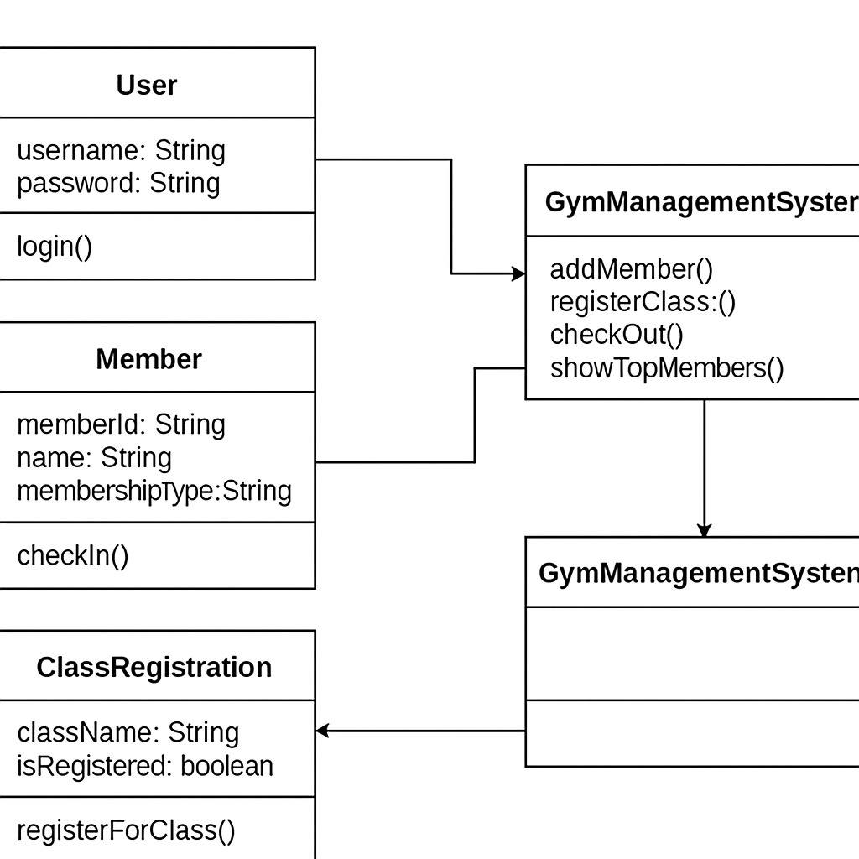

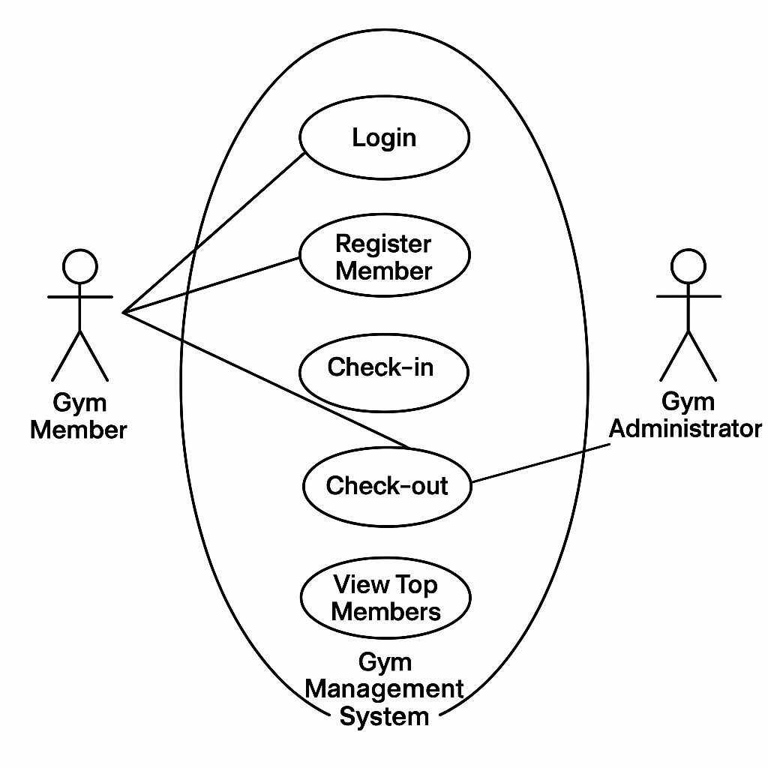

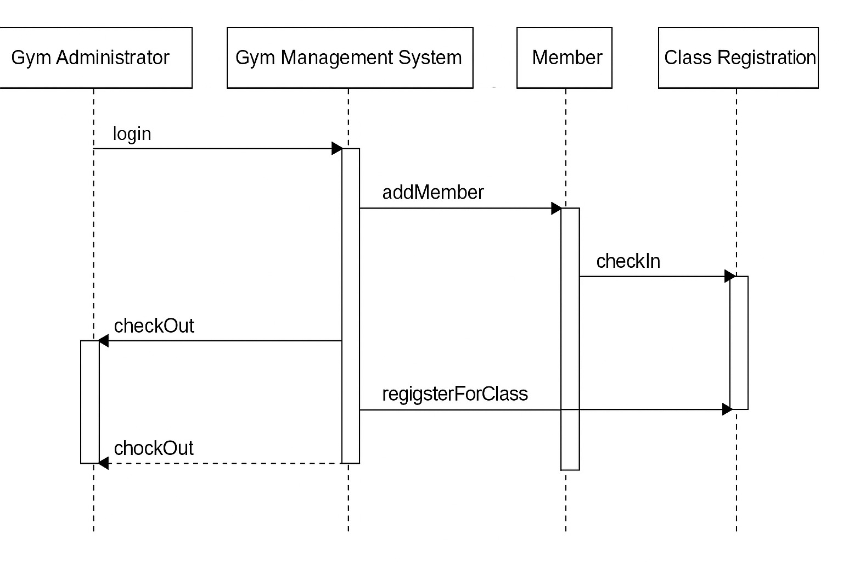

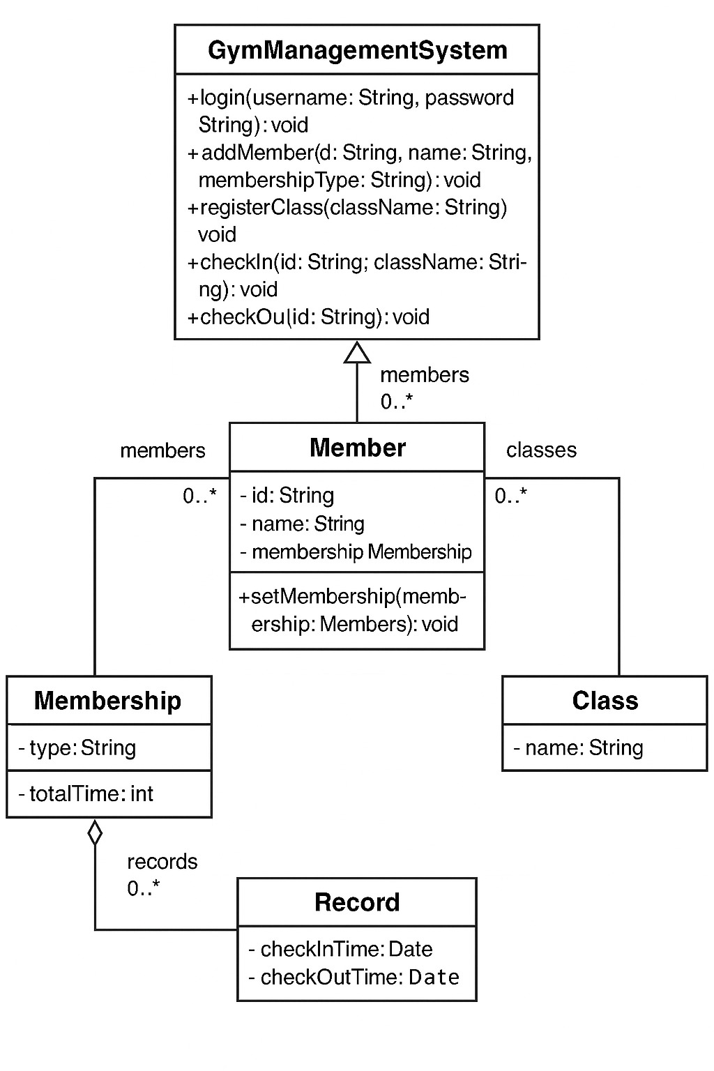

4.Implementation

4.1 Sample code

<!DOCTYPE html>

<html lang="en">

<head>

<meta charset="UTF-8">

<meta name="viewport" content="width=device-width, initial-scale=1.0">

<title>Gym Management System</title>

<style>

body {

font-family: Arial, sans-serif;

margin: 0;

padding: 0;

height: 100vh;

background-image: url("https://images.pexels.com/photos/1229356/pexels-photo-1229356.jpeg?cs=srgb&dl=abs-adult-athlete-1229356.jpg&fm=jpg");

background-size: cover;

background-position: center;

background-repeat: no-repeat;

display: flex;

flex-direction: column;

align-items: center;

justify-content: center;

color: white;

}

#loginContainer, #contentContainer {

width: 80%;

max-width: 800px;

padding: 20px;

border-radius: 10px;

box-sizing: border-box;

}

#loginContainer {

background-color: rgba(0, 0, 0, 0.7);

text-align: center;

}

#contentContainer {

background-color: rgba(0, 0, 0, 0.6);

display: none;

text-align: center;

}

input, select, button {

margin: 5px; /* Reduced margin */

padding: 8px 10px; /* Reduced padding */

border: none;

border-radius: 5px;

font-size: 14px; /* Reduced font size */

width: 150px; /* Reduced width */

box-sizing: border-box;

}

button {

background-color: #3498db;

color: white;

cursor: pointer;

transition: background-color 0.3s;

}

button:hover {

background-color: #2980b9;

}

#output {

border: 2px solid #ccc;

padding: 15px;

height: 200px;

overflow-y: auto;

text-align: left;

margin-top: 20px;

background-color: rgba(255, 255, 255, 0.1);

color: white;

}

.title {

font-size: 2.5em;

font-weight: bold;

margin-bottom: 20px;

text-shadow: 2px 2px 4px rgba(0, 0, 0, 0.8);

}

.section {

margin-bottom: 10px; /* Reduced margin */

}

</style>

</head>

<body>

<div id="loginContainer">

<h2 class="title">Login</h2>

<input type="text" id="username" placeholder="Username">

<input type="password" id="password" placeholder="Password">

<button onclick="login()">Enter</button>

<p id="loginMessage" style="color: red;"></p>

</div>

<div id="contentContainer">

<h2 class="title">Gym Management System</h2>

<div class="section">

<input type="text" id="memberId" placeholder="Member ID">

<input type="text" id="memberName" placeholder="Member Name">

<select id="membershipType">

<option value="" disabled selected>Select Membership Type</option>

<option value="Basic">Basic</option>

<option value="Premium">Premium</option>

<option value="VIP">VIP</option>

</select>

<button onclick="addMember()">Add Member</button>

</div>

<div class="section">

<select id="className">

<option value="" disabled selected>Select Class</option>

<option value="Yoga">Yoga</option>

<option value="Zumba">Zumba</option>

<option value="Cardio">Cardio</option>

<option value="Strength Training">Strength Training</option>

</select>

<button onclick="registerClass()">Register Class</button>

</div>

<div class="section">

<input type="text" id="memberIdAction" placeholder="Member ID">

<select id="classNameAction">

<option value="" disabled selected>Select Class</option>

<option value="Yoga">Yoga</option>

<option value="Zumba">Zumba</option>

<option value="Cardio">Cardio</option>

<option value="Strength Training">Strength Training</option>

</select>

<button onclick="checkIn()">Check In</button>

<button onclick="checkOut()">Check Out</button>

</div>

<button onclick="showTopMembers()">Show Top Members</button>

<h3>Output:</h3>

<div id="output"></div>

</div>

<script>

let members = {};

let checkInTimes = {};

function login() {

let username = document.getElementById("username").value;

let password = document.getElementById("password").value;

document.getElementById("loginContainer").style.display = "none";

document.getElementById("contentContainer").style.display = "block";

}

// Rest of your gym management functions (addMember, registerClass, etc.)

function addMember() {

let id = document.getElementById("memberId").value;

let name = document.getElementById("memberName").value;

let type = document.getElementById("membershipType").value;

if (id && name && type) {

members[id] = { name, type, totalTime: 0 };

log(Added member: ${name} (${type}));

} else {

log('Please enter all details and select a membership type.');

}

}

function registerClass() {

let className = document.getElementById("className").value;

if (className) {

log(Registered class: ${className});

} else {

log('Please select a class to register.');

}

}

function checkIn() {

let id = document.getElementById("memberIdAction").value;

let className = document.getElementById("classNameAction").value;

if (id in members && className) {

checkInTimes[id] = Date.now();

log(Member ${id} checked into ${className}.);

} else {

log('Invalid Member ID or Class Name.');

}

}

function checkOut() {

let id = document.getElementById("memberIdAction").value;

if (id in members && id in checkInTimes) {

let timeSpent = Math.floor((Date.now() - checkInTimes[id]) / 60000);

members[id].totalTime += timeSpent;

delete checkInTimes[id];

log(Member ${id} checked out. Time spent: ${timeSpent} min.);

} else {

log('Invalid check-out attempt.');

}

}

function showTopMembers() {

let sortedMembers = Object.values(members).sort((a, b) => b.totalTime - a.totalTime);

log('Top Members by Time Spent:');

sortedMembers.slice(0, 3).forEach(m => log(${m.name} (${m.type}) - Time Spent: ${m.totalTime} min));

}

function log(message) {

document.getElementById("output").innerHTML += message + "<br>";

}

</script>

</body>

</html>

4.2.TESTCASES:

I. Login Functionality:

1. Valid Login:
   * Input: Username = admin, Password = password
   * Expected Output: The login container (#loginContainer) should be hidden, and the content container (#contentContainer) should be visible. The login message (#loginMessage) should be empty.
2. Invalid Username:
   * Input: Username = user, Password = password
   * Expected Output: The login container should remain visible. The content container should remain hidden. The login message should display "Invalid username or password."
3. Invalid Password:
   * Input: Username = admin, Password = wrongpassword
   * Expected Output: The login container should remain visible. The content container should remain hidden. The login message should display "Invalid username or password."
4. Empty Username:
   * Input: Username = ``, Password = password
   * Expected Output: The login container should remain visible. The content container should remain hidden. The login message should display "Invalid username or password."
5. Empty Password:
   * Input: Username = admin, Password = ``
   * Expected Output: The login container should remain visible. The content container should remain hidden. The login message should display "Invalid username or password."
6. Empty Username and Password:
   * Input: Username = , Password =
   * Expected Output: The login container should remain visible. The content container should remain hidden. The login message should display "Invalid username or password."

II. Add Member Functionality:

1. Adding a Valid Member:
   * Input: Member ID = 101, Member Name = Alice, Membership Type = Premium
   * Expected Output: The output div (#output) should display "Added member: Alice (ID: 101, Premium)". The members object should contain an entry for ID 101 with the correct name, type, and totalTime of 0. The input fields for Member ID and Name should be cleared, and the Membership Type dropdown should be reset.
2. Adding a Member with Missing Information (ID):
   * Input: Member ID = ``, Member Name = Bob, Membership Type = Basic
   * Expected Output: The output div should display "Please enter all details and select a membership type." No member should be added to the members object.
3. Adding a Member with Missing Information (Name):
   * Input: Member ID = 102, Member Name = ``, Membership Type = VIP
   * Expected Output: The output div should display "Please enter all details and select a membership type." No member should be added to the members object.
4. Adding a Member without Selecting Membership Type:
   * Input: Member ID = 103, Member Name = Charlie, Membership Type = (default "Select Membership Type")
   * Expected Output: The output div should display "Please enter all details and select a membership type." No member should be added to the members object.
5. Adding a Member with an Existing ID:
   * Steps:
     + Add a member with ID 201 and any other valid details.
     + Attempt to add another member with the same ID 201 but different name and type.
   * Expected Output (second attempt): The output div should display "Member ID 201 already exists." The original member information for ID 201 in the members object should remain unchanged.

III. Register Class Functionality:

1. Registering a Valid Class:
   * Input: Class Name = Yoga
   * Expected Output: The output div should display "Registered class: Yoga (This action doesn't associate with a member yet)." The Class Name dropdown should be reset.
2. Registering Without Selecting a Class:
   * Input: Class Name = (default "Select Class")
   * Expected Output: The output div should display "Please select a class to register."

IV. Check-In Functionality:

1. Valid Check-In:
   * Prerequisite: A member with a valid ID (e.g., 301) must be added.
   * Input: Member ID = 301, Class Name = Zumba
   * Expected Output: The output div should display "Member Alice (ID: 301) checked into Zumba." (Assuming the member's name is Alice). The checkInTimes object should contain an entry for ID 301 with a startTime and the class as "Zumba". The input fields for Member ID and Class Name should be cleared.
2. Check-In with Invalid Member ID:
   * Input: Member ID = 999 (non-existent), Class Name = Cardio
   * Expected Output: The output div should display "Invalid Member ID or Class Name for check-in." The checkInTimes object should remain unchanged.
3. Check-In Without Selecting a Class:
   * Prerequisite: A member with a valid ID must be added.
   * Input: Member ID = (valid ID), Class Name = (default "Select Class")
   * Expected Output: The output div should display "Invalid Member ID or Class Name for check-in." The checkInTimes object should remain unchanged.
4. Attempting to Check-In an Already Checked-In Member:
   * Steps:
     + Check-in a member with a valid ID into a class.
     + Attempt to check-in the same member into a different class.
   * Expected Output (second attempt): The output div should display "Member [Member Name] (ID: [Member ID]) is already checked in." The checkInTimes entry for that member should remain with the initial check-in time and class.

V. Check-Out Functionality:

1. Valid Check-Out:
   * Prerequisite: A member must be checked in.
   * Steps:
     + Check-in a member (e.g., ID 401) into a class.
     + Click the "Check Out" button with the same Member ID (401).
   * Expected Output: The output div should display "Member [Member Name] (ID: 401) checked out from [Class Name]. Time spent: [some number] min." The entry for ID 401 should be removed from the checkInTimes object. The totalTime for member 401 in the members object should be updated with the calculated time spent. The input fields for Member ID and Class Name should be cleared.
2. Check-Out with Invalid Member ID:
   * Input: Member ID = 888 (non-existent)
   * Expected Output: The output div should display "Invalid check-out attempt or member not checked in." The checkInTimes and members objects should remain unchanged.
3. Attempting to Check-Out a Member Who is Not Checked In:
   * Input: Member ID = (valid ID of a member who hasn't checked in)
   * Expected Output: The output div should display "Invalid check-out attempt or member not checked in." The checkInTimes and members objects should remain unchanged.

VI. Show Top Members Functionality:

1. No Members Checked Out:
   * Action: Click the "Show Top Members" button without any members having checked out.
   * Expected Output: The output div should display "<h3>Top Members by Time Spent:</h3>" followed by "No members have checked out yet."
2. One Member Checked Out:
   * Steps:
     + Add a member and have them check-in and then check-out.
     + Click the "Show Top Members" button.
   * Expected Output: The output div should display "<h3>Top Members by Time Spent:</h3>" followed by "1. [Member Name] ([Membership Type]) - Time Spent: [total time] min".
3. Multiple Members Checked Out (Less Than 3):
   * Steps:
     + Add two members and have them check-in and then check-out for different durations.
     + Click the "Show Top Members" button.
   * Expected Output: The output div should display "<h3>Top Members by Time Spent:</h3>" followed by the two members listed in descending order of their totalTime.
4. Multiple Members Checked Out (More Than 3):
   * Steps:
     + Add four or more members and have them check-in and then check-out for different durations.
     + Click the "Show Top Members" button.
   * Expected Output: The output div should display "<h3>Top Members by Time Spent:</h3>" followed by the top three members listed in descending order of their totalTime.

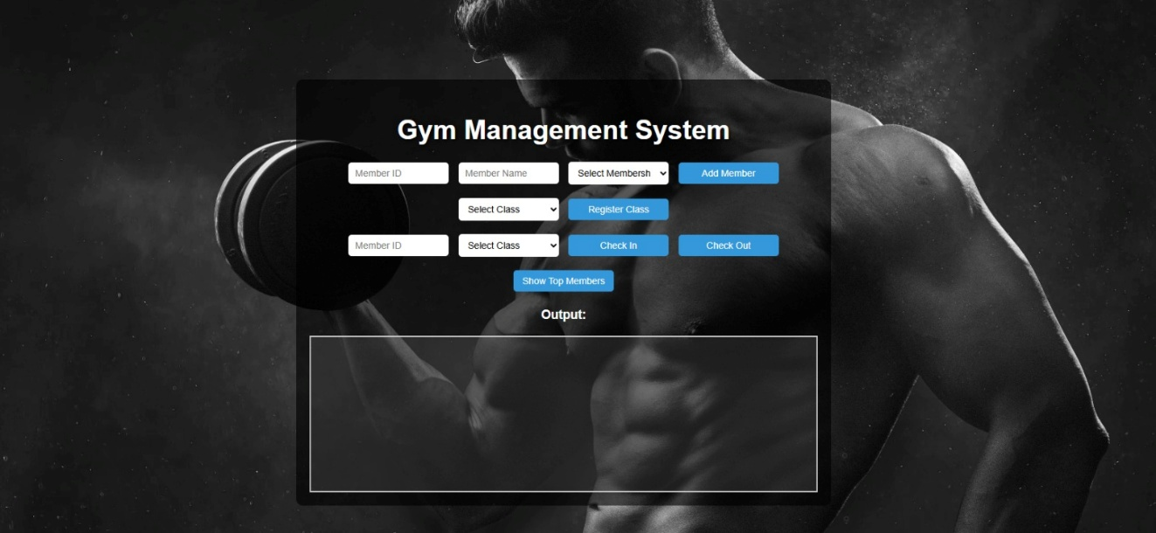RESULT:



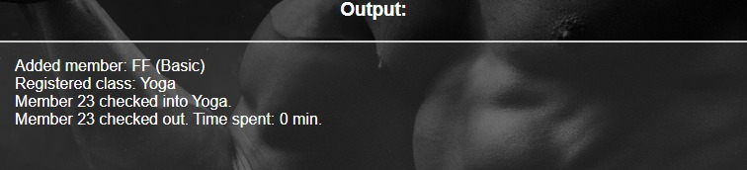

6.Conclusion

Conclusion of the Gym Management System

This HTML and JavaScript code provides a basic framework for a Gym Management System with the following core functionalities:

Login: A simple login screen to control access to the main system features.

Member Management: Adding new members with a unique ID, name, and membership type.

Class Registration: A feature to register different gym classes (although this version doesn't link registrations to specific members).

Check-In/Check-Out: Tracking member attendance by allowing them to check in and out of the gym. The system records the time spent by each member.

Top Members: Displaying the top three members based on the total time they have spent at the gym.

Output Logging: A dedicated section to display system messages and activity logs.

Strengths:

Client-Side Implementation: The system is implemented entirely on the client-side using HTML, CSS, and JavaScript. This makes it relatively simple to deploy and run in any modern web browser without requiring a server-side backend or database.

Basic Functionality: It covers the fundamental aspects of gym management, such as member tracking and attendance.

Clear User Interface: The HTML and CSS provide a reasonably clean and understandable user interface, given its simplicity.

Illustrative Example: It serves as a good example of how to manage data and user interactions within a web page using JavaScript.

Limitations and Potential Improvements:

No Data Persistence: The member data (members) and check-in times (checkInTimes) are stored in the browser's memory. This means that if the user closes the browser or refreshes the page, all the data will be lost. A significant improvement would be to implement data persistence using technologies like Local Storage, Session Storage, or a server-side database.

Simple Login: The login mechanism is very basic and hardcoded in the JavaScript. For a real-world application, a more secure authentication system with user roles and password hashing would be necessary.

Class Registration Limitations: The "Register Class" functionality currently doesn't associate members with specific classes or track class attendance. Enhancements could include linking members to classes, managing class schedules, and tracking capacity.

Error Handling: The error handling is basic (e.g., checking for empty fields). More robust error handling and validation would improve the system's reliability.

Scalability: For a large gym with many members and activities, this client-side approach would likely become inefficient and difficult to manage. A server-side architecture with a database would be more scalable.

Real-time Updates: The current system doesn't offer real-time updates or interactions between multiple users or devices.

Lack of Features: Many common gym management features are missing, such as membership management (renewal, expiry), payment processing, workout tracking, staff management, reporting, etc.